**Flying V**

**RULES:** BLGC Rulebook, Latest Edition **COURSE DESIGNER:** Kirt McKenna

|  |  |
| --- | --- |
| **START POSITION:** Standing facing downrange with toes on X’s. Rifle is loaded, safety on, in low-ready position. | |
| **STAGE PROCEDURE**  On start signal engage targets as they become visible, from within the shooting area. | **SCORING**  **SCORING:** Comstock, 24 rounds, 120 points  **TARGETS:** 12 paper  **SCORED HITS:** 2Best per Paper  **START-STOP:** Audible - Last shot  **PENALTIES:** Per current BLGC rulebook |

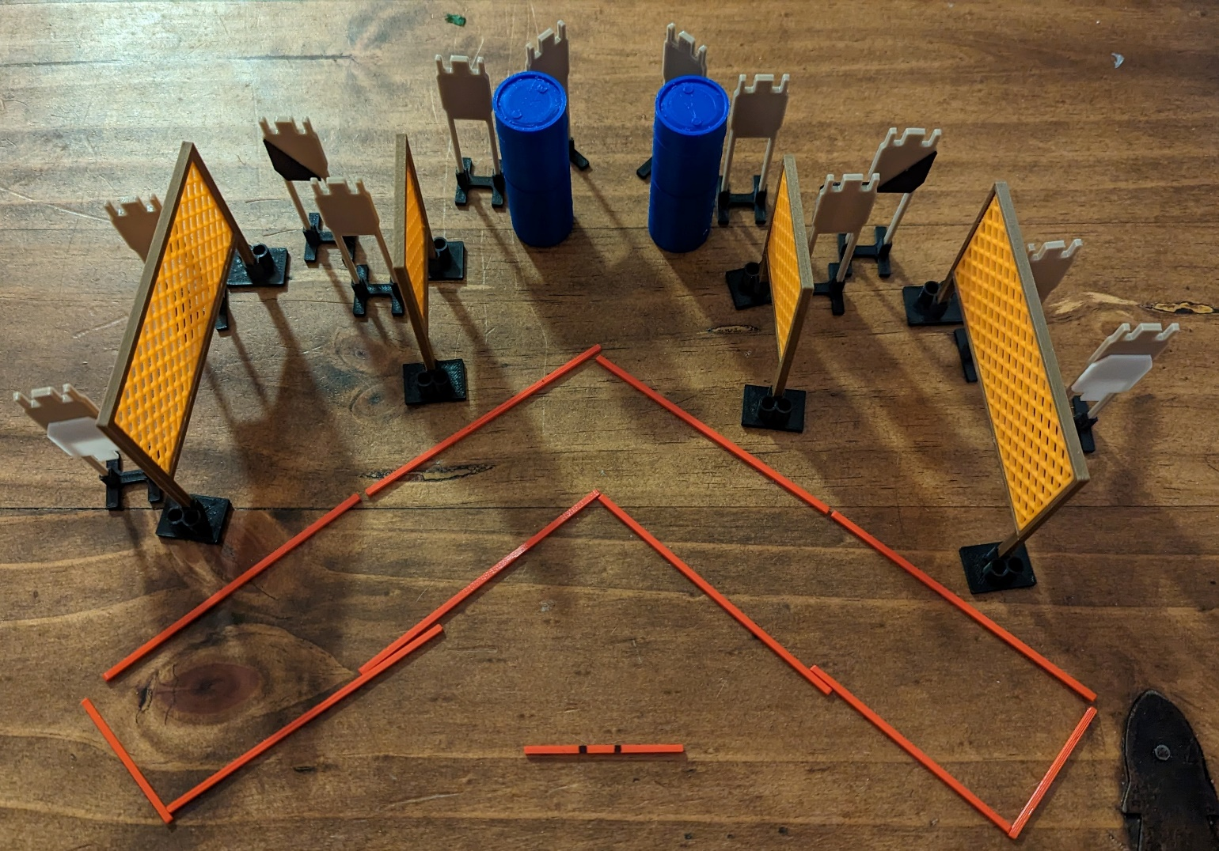

**SHOOTING AREA**

**X X**

|  |  |  |
| --- | --- | --- |
| **SETUP NOTES**: Prevent shoot-throughs |  | **RO NOTES**: |